



**SFCC - Kount 360 Payments Fraud Implementation Guide**

|  |
| --- |
| **Client Success** |
| **22.08.2025** |
| **Version 1.0.0**  **DISCLAIMER:** This is an internal document of Equifax Inc. Distribution to third parties is unauthorized. Equifax Inc. believes this information to be accurate as of the date of publication but makes no guarantees with regard to the information or its accuracy. All information is subject to change without notice. All company and product names used herein are trademarks of their respective owners. |
| Copyright ©2025, Equifax Inc.,  All rights reserved.  Equifax and the Equifax marks used herein are trademarks of Equifax Inc. Kount is a trademark of Equifax Inc. Other product and company names mentioned herein are the property of their respective owners. |

## 

## Table of Contents

**Table of Contents 2**

**Overview 2**

**Prerequisites 3**

**Implementation 3**

Import Metadata 3

Update site cartridge path 5

Site Preferences 6

**Kount Command - Kount 360 Custom Mappings 7**

Kount 360 Custom Mappings 7

**Kount 360 Webhook configuration 9**

**Services 10**

**Jobs 10**

## 

## **Overview**

Kount is a leading innovator of solutions for fraud and risk management. Kount's “decision engine” platform is ideal for managing fraud in online/telephone channels that process payments and onboard new customers. Kount is committed to offering an end-to-end, single-source solution focused on speed, simplicity and ease of use...with a no-compromise approach to providing real-time accuracy in results.

The Kount SFCC cartridge will provide rapid integration for SFCC implementations. The Kount cartridge is a self-contained cartridge that can easily integrate into any project. This cartridge can be configured in the Business Manager and contains all elements necessary to perform a successful best practices implementation of Kount.

**Kount 360 SFRA** cartridge extends the base logic from the **int_kount** cartridge, which is used for integration of the legacy Kount Command with the Salesforce Commerce Cloud.

Changed workflows:

1. Kount RIS (Risk inquiry service) workflow is being extended, by replacing the legacy Command RIS endpoint request with the Kount 360 Orders API endpoint, which upgrades the core logic with the Payments Fraud system that includes features such as improved Omniscore accuracy during an order evaluation process.
2. Kount ENS (Event Notification system) is being extended, by replacing it with the Kount 360 Webhooks, for improved Payment fraud events handling system.

## **Prerequisites**

1. Active Salesforce Commerce Cloud instance;
2. Salesforce’s Storefront Reference Architecture (SFRA)
3. Kount (**int_kount**) integrational cartridges must be installed, including all metadata, jobs and services. For more information follow the [Kount Developer - Salesforce Implementation Guide](https://developer.kount.com/hc/en-us/articles/5715606098708-How-to-Implement-SalesForce-Commerce-Cloud#_QUICKLINK_1)
4. A SFCC Development Resource: The Integration and installation process includes deployment of a generic cartridge and modification of storefront code & controllers

## **Implementation**

### **Import Metadata**

To import the metadata, acquire the metadata files, located in the Kount repository with the latest version of the cartridge. Before importing, use a compression tool to archive the “**metadata”** folder from the **SFCC Kount K360** project into a .zip file.

For *Windows*, use any type of compressing tool, to archive the “metadata” folder, into a .zip archive. For example (*Windows 11*):

For *MacOS*, right-click on the metadata folder, and select **Compress “metadata”**, which will create a **metadata.zip** archive in the same folder.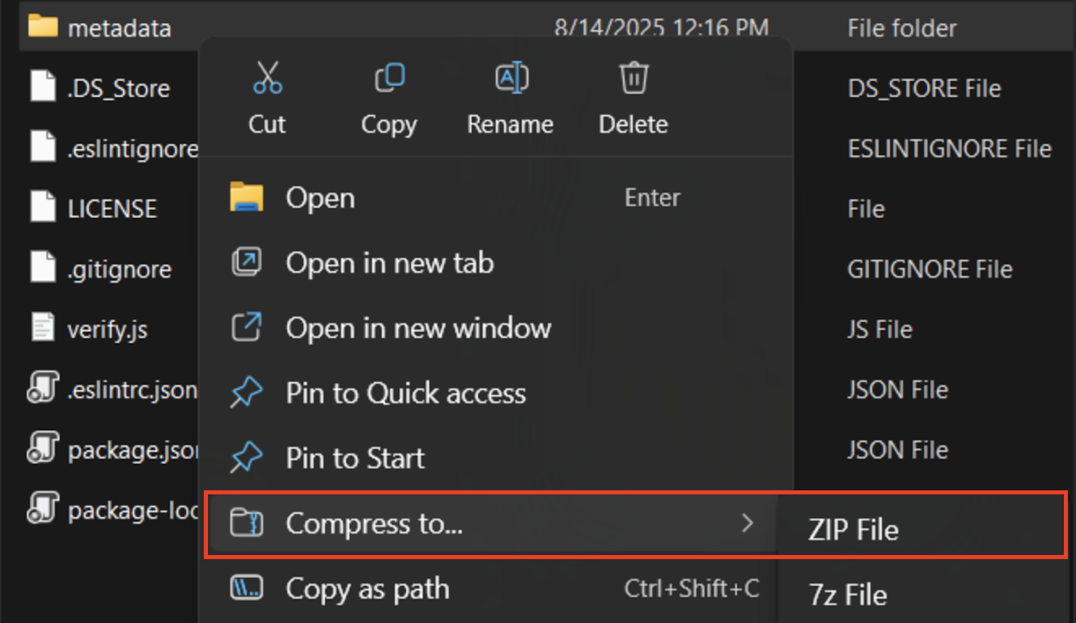

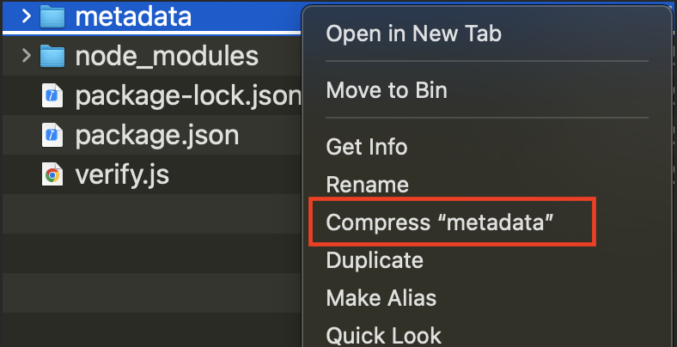

In SFCC Business Manager, go to Administration >> Site Development >> Site Import & Export. Select the **metadata.zip** file from a local machine and upload it.

After uploading the file on the SFCC instance, select it from the menu below , the select **Import**; (Note: Confirmation of the import may be required)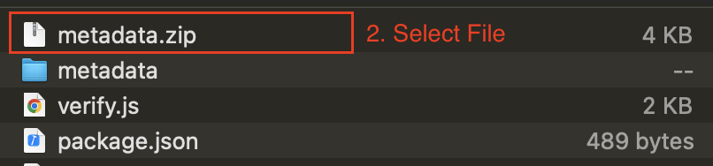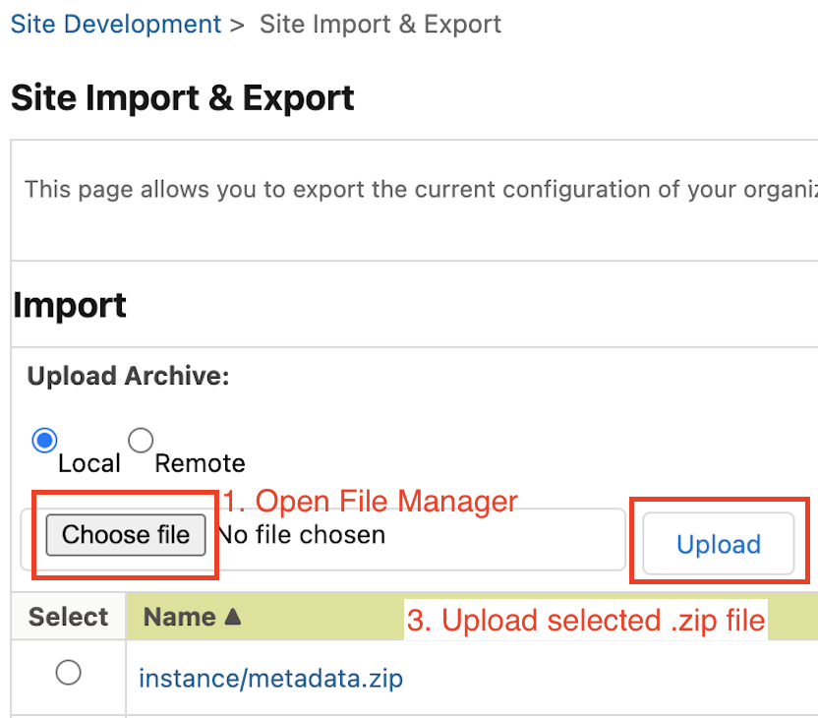

### **Update site cartridge path**

For the cartridge to be assigned to the website, it must firstly be uploaded to an SFCC instance.

After the upload of the **int_kount_360_sfra** cartridge is done, proceed with the following setup guidelines:

1. In Salesforce Business Manager, go to Administration >> Sites >> Manage Sites.
2. Select a Site, for the cartridge to be assigned;
3. Open the Settings tab;  
     
     
     
     
     
   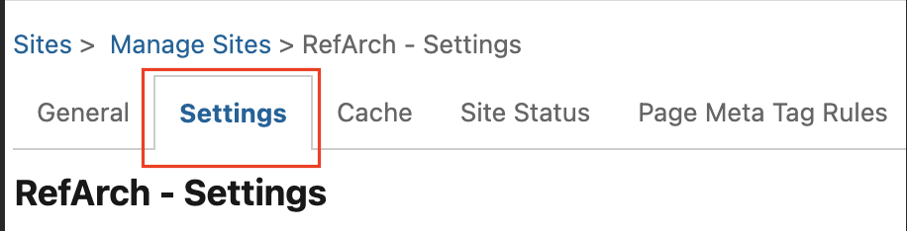
4. Enter the following text into the **Cartridges** field - **int_kount_360_sfra:int_kount:**  
     
   NOTE : Be sure to include the colon.
5. Choose the **Apply** button.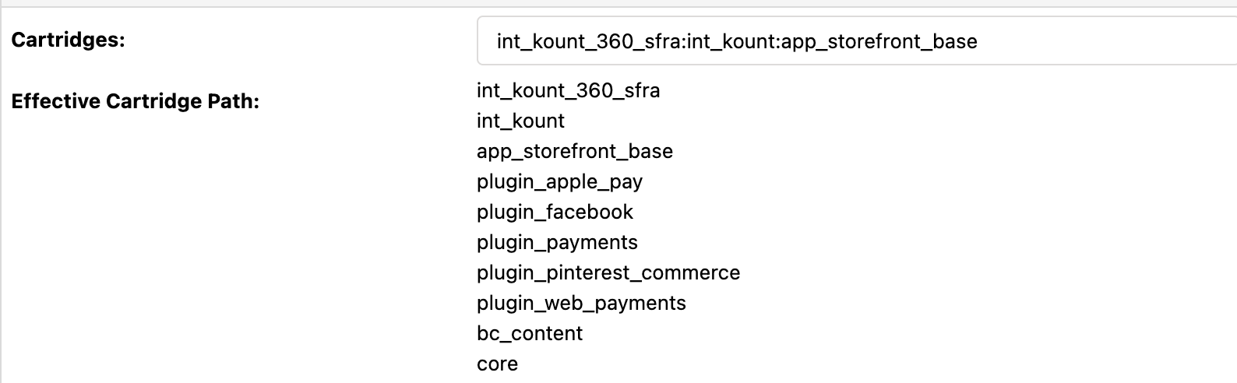

### **Site Preferences**

The Kount 360 Site Preferences will need to be filled into the fields within this section. The script file will display the default values to the right of the screen, but does not populate the fields automatically.

Verify the Site Preferences by opening the SFCC business manager and navigating to **Merchant Tools -> Site Preferences -> Custom Preferences**. Select **Payments Fraud in Kount 360** group.

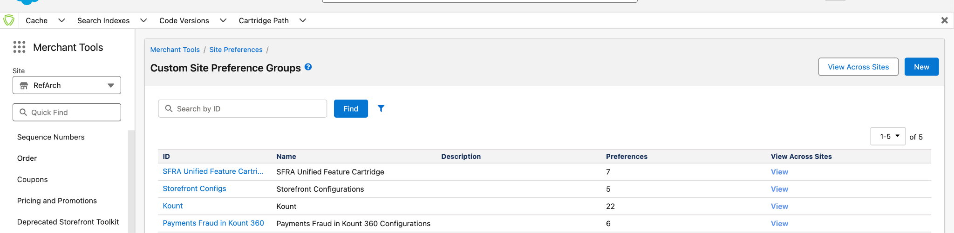

|  |  |
| --- | --- |
| Preference name | Description |
| Enable Payments Fraud | Enables/Disables the Kount 360 functionality for the website |
| Auth Token API key | API key that needs to be configured in order for the services to be able to access the Kount 360 API. The API Key needs to be acquired through the Kount 360 Portal.  Note: Each API key can only be generated once. After generating the API Key, store it in a safe directory. |
| Enable Webhooks | Enables/Disables Kount 360 Webhooks functionality; |
| Webhook Public API Key | API key used to verify webhook requests. The public key can be copied directly from the Kount 360 Portal; |
| Webhook Grace Period | Period of time (is seconds), in which webhook requests will be accepted after being sent from Kount 360. |
| Enable Legacy ENS Storage | Enables/Disables Webhook event data processing via the legacy Kount Command job. |

## **Kount Command - Kount 360 Custom Mappings**

In the Kount 360 extension, there are situations where the legacy Kount Command data objects properties must be altered to match the required logic from the Kount 360 API.

The following section explains the mapping configurations.

There are 2 types of mappings: Transformational and Custom Values Mappings:

* **Transformational mappings (T)** - transform an entire data object using a pre-defined property mapping into a new object that aligns with the extended workflow.
* **Custom Values Mappings (CV)** - transforms the values on some of the properties of an data object, by following a pre-defined value-to-value mapping for each property field.

Each of the custom mappings is defined with a JSON formatted key-value definition. The definition depends on the type of the mapping.

For **T** mappings, in each definition the **key** defines a property for the transformed object. It can be flat (e.g., "sku") or nested (e.g., "items.[*].price"). The **value** of the property, specifies the source property from the input object.

Note: When defining a nested property, the [*] placeholder indicates that the property is part of an array.

* The portion before [*] specifies the array’s path.
* The portion after [*] specifies the property of each object within that array.
* The [*] placeholder must appear only once per mapping definition.

For **CV** mappings, the **key** defines the property for which the mapping will be applied, and the value is an object that defines a value-to-value mapping for that property..

Custom mappings are configurable from the **int_kount_360_sfra** cartridge, inside the ***int_kount_360_sfra/kount360mappings*** folder.

### Kount 360 Custom Mappings

|  |  |  |
| --- | --- | --- |
| Mapping name | Type | Description |
| kount360ReqMapping | T | Transforms Kount Command RIS Query object into a format used for the Orders POST API request.  Input Object: Kount Command RIS POST request |
| kount360ReqValuesMapping | CV | Applies custom mappings for the values of the object created by the **kount360ReqMapping**. |
| kount360ResMapping | T | Transforms Kount Command RIS Query object into a format used for the Orders POST API response.  Input Object: Kount Command RIS POST response |
| kount360ResValueMapping | CV | Applies custom mappings for the values of the response object created by the **kount360ResMapping**. |
| kount360WebhookToENSMapping | T | Transforms a Webhook event object to match the legacy Kount Command ENS object structure, to be stored as an ENS record before being processed by the Kount-ProcessENSQueue job.  Input Object: Kount 360 Webhook request body  Note: **Enable Legacy ENS Storage** site preference must be activated for this mapping to be enabled. |
| kount360WebhookToENSValueMapping | CV | Applies custom mappings for the values of the webhook event record object created by the **kount360WebhookToENSMapping**.  Note: **Enable Legacy ENS Storage** site preference must be activated for this mapping to be enabled. |

## **Kount 360 Webhook configuration**

In order for a website to receive webhook event information, a webhook must be configured in the Kount 360 for the website(channel).

In the Business Manager, select a website, then go to Merchant tools >> Site Preferences >> Custom Preferences. Select the Kount site preference group and get the Website ID preference.   
(Fill the value if missing. Reference link [here](https://developer.kount.com/hc/en-us/articles/5715606098708-How-to-Implement-SalesForce-Commerce-Cloud#_QUICKLINK_1:~:text=over%20the%20phone.-,Website%20ID,-%3A%20Typically%20default));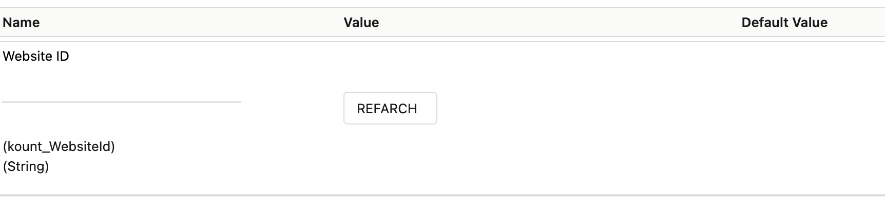

In the Kount 360 Portal, go to Admin >> Product Management >> System Settings >> Webhooks, and create a new webhook configuration for the website (channel).

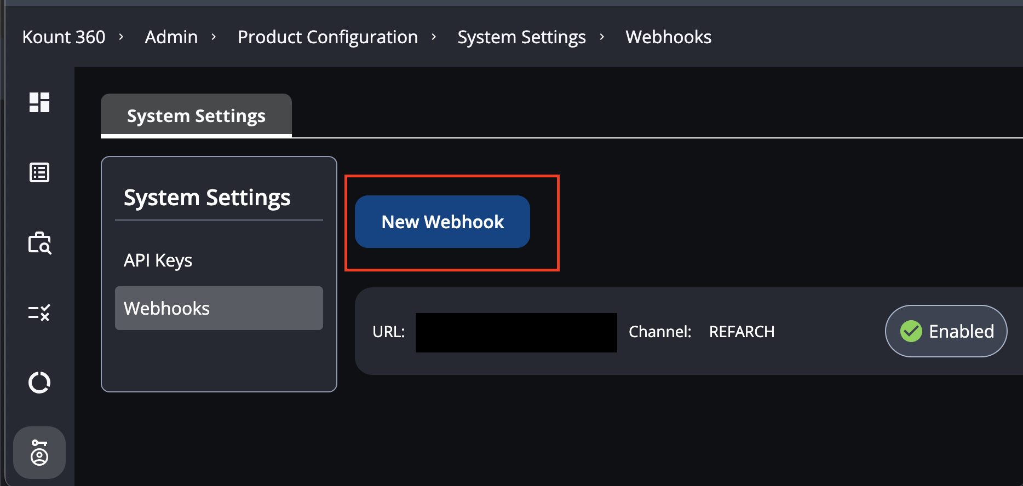

1. Choose webhook event types. (Example: Order Status Changed)
2. For channel input the Website ID.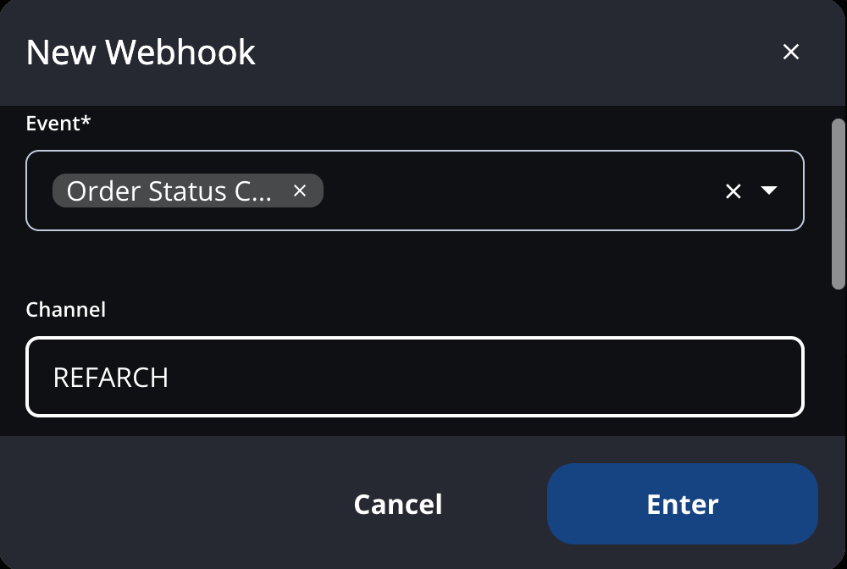
3. For URL insert the full https url for the Kount360-Webhook endpoint for the website.

Pattern:   
https://{SFCC_INSTANCE}/on/demandware.store/Sites-{SITE_ID}-Site/{locale}/Kount360-Webhook

1. Select “Enter” to create the webhook

## 

## **Services**

To establish connection with the Kount 360 API, a service configuration needs to be installed.

This integration Kount 360 features 2 services configurations:

* Kount 360 Auth Token service - used for fetching authentication token bearer to be used for future API calls. Every token is stored inside the SFCC custom cache, with an expiration time of 19 minutes, before being revoked.
* Kount 360 API REST service - used for executing requests to Kount 360 API.

## **Jobs**

During the Payment Fraud investigation process, webhooks calls could be established to SFCC. Each webhook contains data on events that need to be handled by the Commerce cloud in order to update the state of existing Orders. The **Kount360-ProcessWebhookQueue** job is periodically executed in order to process the pending webhook event data that is being stored in the system.